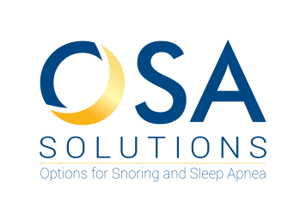 **Dr. Cecilia Ng, DMD**

**#603 – 1788 West Broadway**

**Vancouver, BC V6J 1Y1**

**Phone: 604-318-8633**

**www.osasolutions.ca**

|  |
| --- |
| **Referral For Oral Appliance Therapy** |

**Patient Name _________________________________________________________________**

**DOB (dd/mm/yy) _________________________ Email ______________________________**

**Pt Phone ________________________________ Pt Cell _____________________________**

**Address _____________________________________________________________________**

**City ___________________________________ Postal Code _________________________**

|  |
| --- |
| **Please Fax to 604-872-8889 or Email to** [**info@osasolutions.ca**](mailto:info@osasolutions.ca)  **Include a copy of sleep study report and diagnosis if available** |

**Please Indicate**

**Trialed CPAP Yes/No Wears CPAP Yes/No CPAP Intolerant Yes/No**

|  |
| --- |
| **Treatment Prescription For Oral Appliance Therapy** |

**Physician Name _______________________________**

**Physician Signature ____________________________**

**Date ________ / ___________ / ___________ ______________________________**

**Office Stamp**